Press Release
30. January 2026

Industry coalition calls for clear framework to unlock offshore O&M fleet electrification in the UK
The Offshore Charging Working Group, a broad coalition from across the offshore wind and maritime value chain, is working to address the remaining barriers to decarbonising offshore service operations through the electrification of service operation vessels (SOVs) and crew transfer vessels (CTVs).
The group has concluded that early design consideration and commercial clarity on access to offshore power for charging are the key outstanding challenges.
The Offshore Charging Working Group brings together vessel owners, technology providers, industry organisations and is supported by tier 1 wind farm developers, reflecting a shared ambition to enable electric CTV and SOV operations within offshore wind farms. Industry readiness to deploy zero-emission vessels is growing, provided a clear and workable policy framework is in place.
The group has engaged with The Crown Estate, the UK Department for Energy Security and Net Zero (DESNZ), and Low Carbon Contracts Company (LCCC), highlighting the need for design allowance during early FEED phases, clarity on offshore power access, pricing treatment under the Contracts for Difference (CfD) scheme, and physical access to offshore charging infrastructure.
“Technology is no longer the limiting factor. What industry needs now is clear, practical guidance from authorities to enable offshore charging to move from concept to delivery,” says Øystein Huglen, representing Maritime CleanTech in the working group.
A detailed proposition paper outlining practical policy enablers for offshore charging will be published shortly.

Issued on behalf of the Offshore Charging Working Group, which includes ORE Catapult, NOF, Norwegian Offshore Wind, Seaonics, MJR Power & Automation, Stillstrom by Maersk, Maritime Cleantech, Bibby Marine and Tidal Transit.
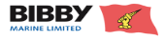






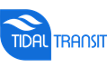


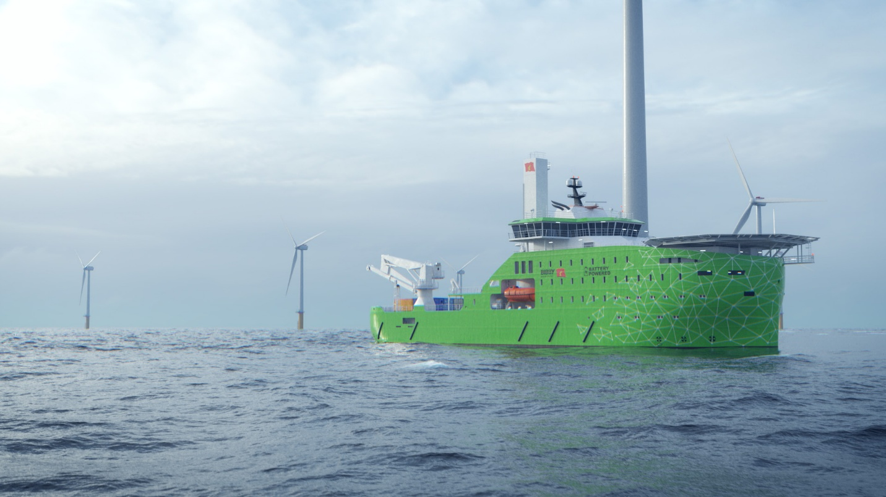
Image Credit: Bibby Marine.

For more information, please contact:
Øystein Huglen
Head of Technology and Innovation
Maritime CleanTech

Tel: +47 952 50 782
E-mail: oystein@maritimecleantech.no

